**Assignment 1:**

Analyze a given business scenario and create an ER diagram that includes entities, relationships, attributes, and cardinality. Ensure that the diagram reflects proper normalization up to the third normal form.

**ANS:**

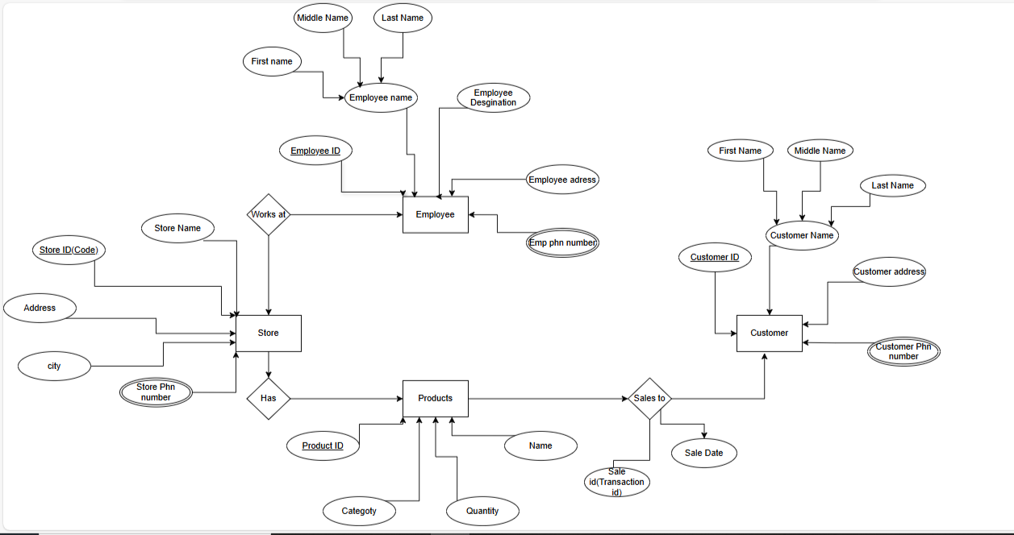ER Diagram: Store Management

**Relationships:**

* A **store** has many **employees**.
* A **store** has many **products**.
* A **product** belongs to one **category**.
* Product can buy by one **customer** but a **customer** can buy many **Products**.

**Entities:**

* Employee
* Products
* Store
* Customer

**Attributes:**

**Store (Entity):** Store Name , Store_id(Primary Key), Address, city, Store phn_number(Multiple values stores).

**Employee (Entity):** Emp_id(Primary key), Employee Designation, Employee address, Employee Phn_number (Multiple values stores), Employee name.

In Employee name attribute: First name, middle name, end name.

**Products (Entity) :** Category, Product_id(Primary key), Quality, Name.

**Customer (Entity) :** Customer_id(Primary key), Customer address, Customer phone number(Multiple values stores), Customer Name.

In Customer name attribute: First name, Last name, middle name.